DATA SCIENCE  
SQL MINI PROJECT – L1S

**INSIGHT 1:** Find the all records present in the cars24 dataset

**QUERY:** Select * from cars24;

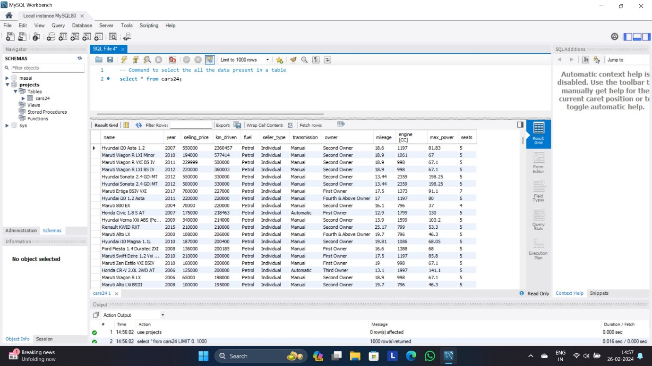

**INSIGHT 2:** Find the cars with manual transmission sort the result in alphabetical order of name.

**QUERY:** select * from cars24 where transmission=’manual’ order by name;

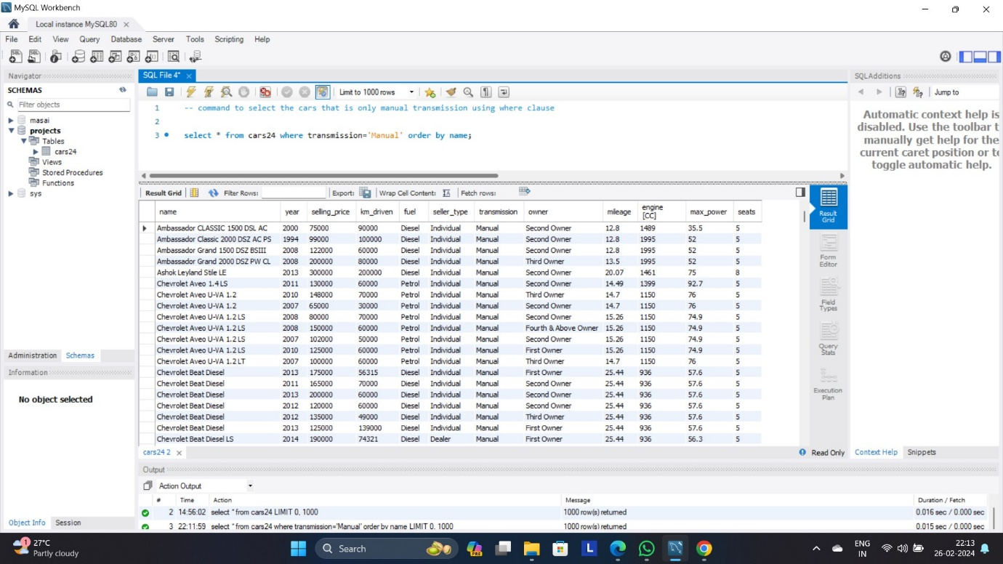

**INSIGHT 3:** count the number of records present in the cars24 dataset;

**QUERY:** select count(*) as total_no_of_records from cars24;

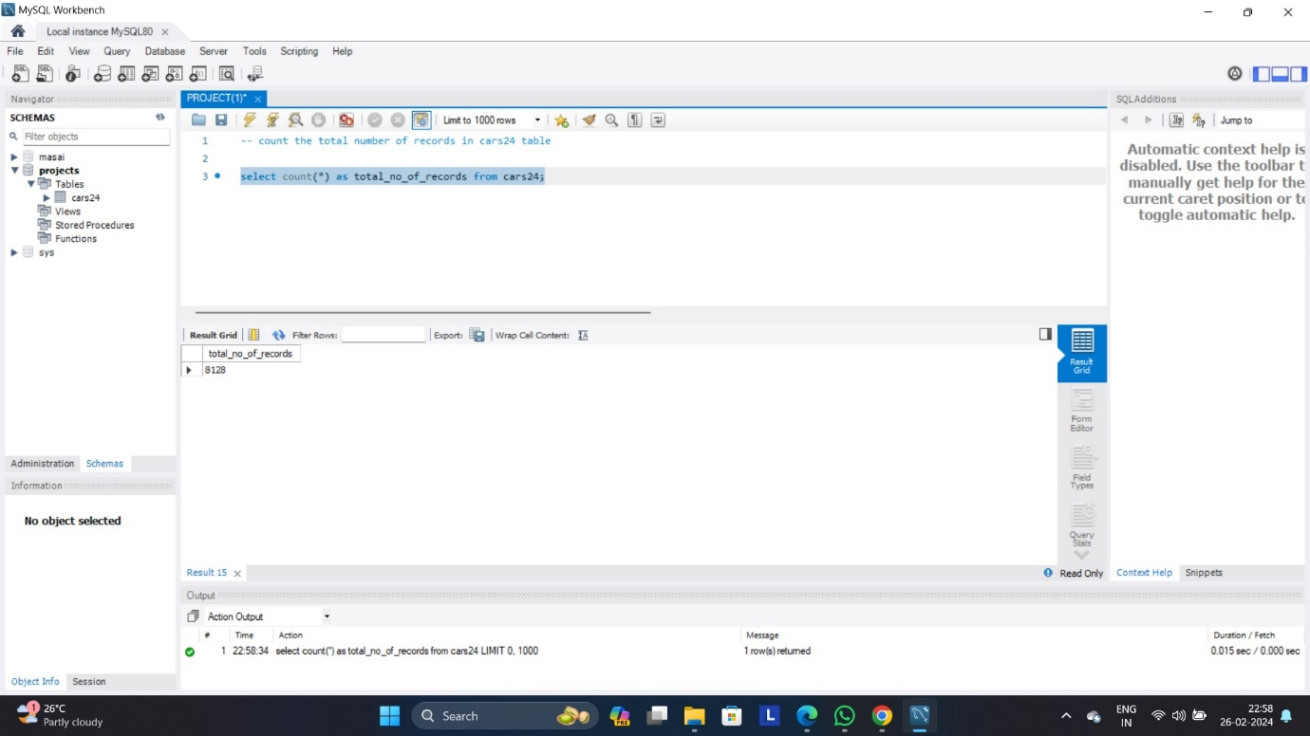

**INSIGHT 4:** Print the different jaguar cars in the table and sort the result in alphabetical order of name

**QUERY:** select distinct * from cars24 where name like ’%Jaguar%’ order by name;

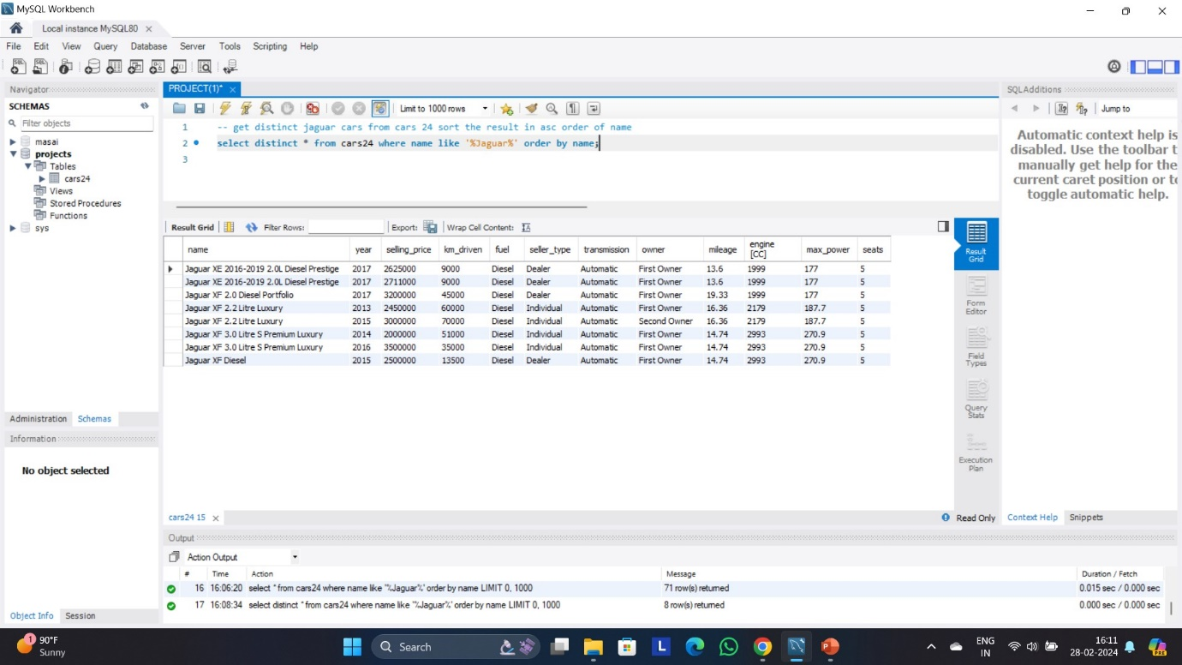

**INSIGHT 5:** Arrange the table by the lowest value first in the table

**QUERY:** select * from cars24 order by selling_price asc;

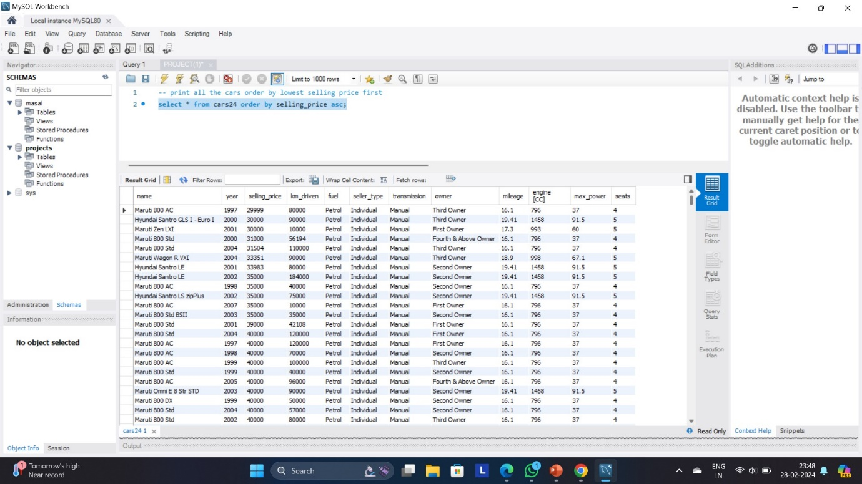

**INSIGHT 6:** Print the top 5 expensive cars in the table.

**QUERY:** select * from cars24 order by selling_price desc limit 5;

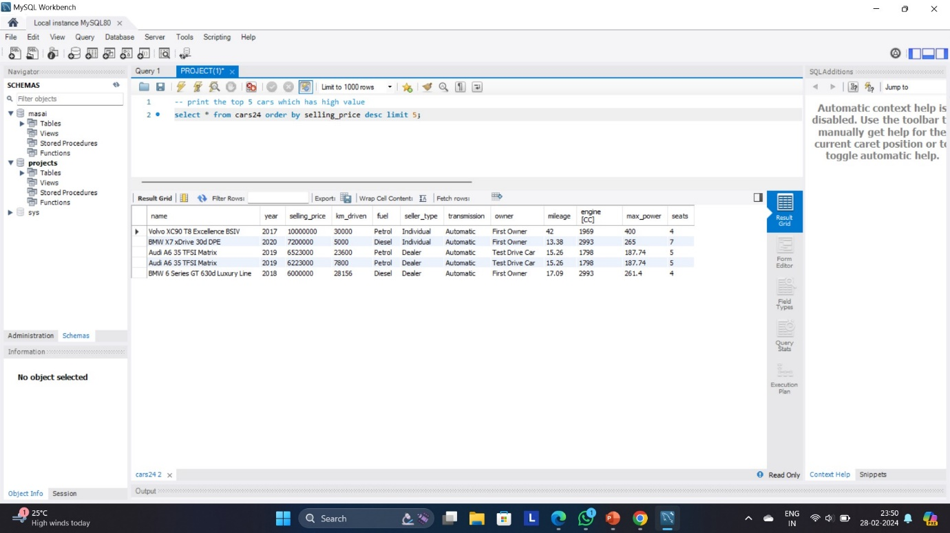

**INSIGHT 7:** Print the first car in the table.

**QUERY:** select * from cars24 order by year limit 1;

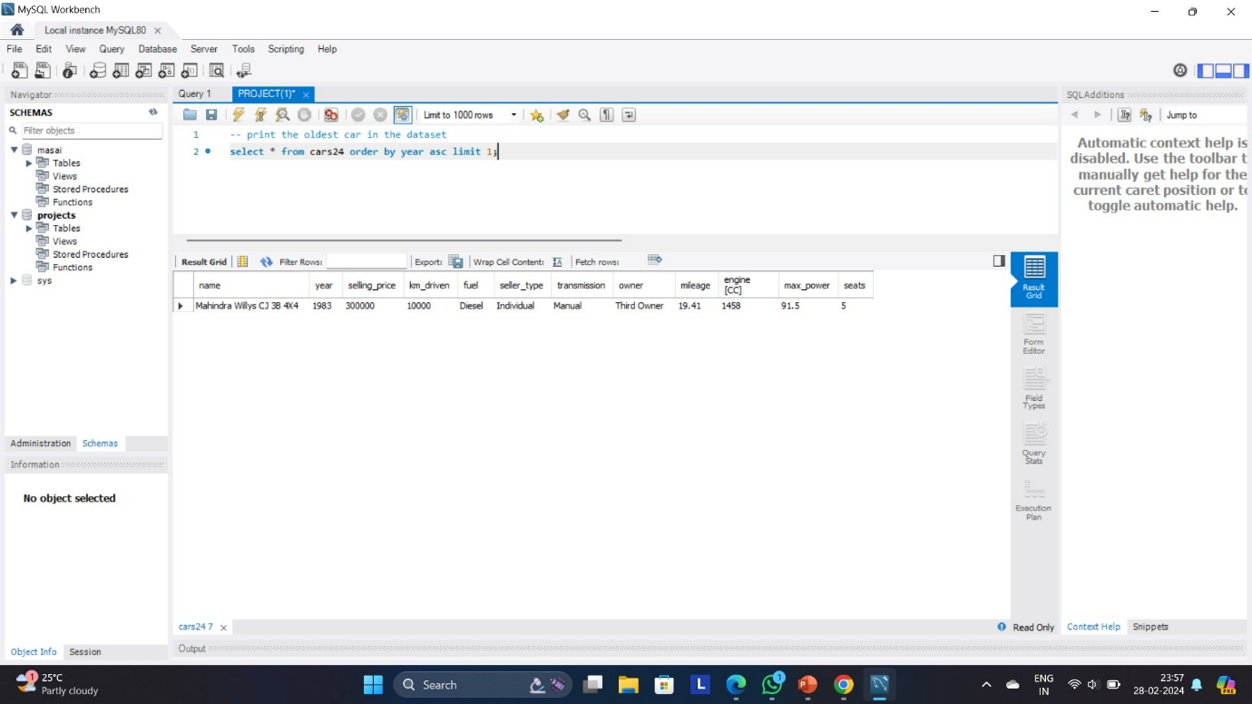

**INSIGHT 8:** categorize the cars into 4 parts according to selling,When the price>6000000 then ‘luxury car’,When the price between 4000000 and 6000000 then ‘premium car’,When the price between 4000000 and 2000000 then ‘High class car’,When the price between 2000000 and 1000000 then ‘Average class car’,Else normal car

**QUERY:** select

Case When the selling_price>6000000 then ‘luxury car’

When the selling_price between 4000000 and 6000000 then ‘premium car’

When the selling_price between 4000000 and 2000000 then ‘High class car’

When the selling_price between 2000000 and 1000000 then ‘Average class car’

Else ‘Normal Car’

End as car_category,count(*) as total_no_of_cars from cars24 group by car_category order by total_no_of_cars;

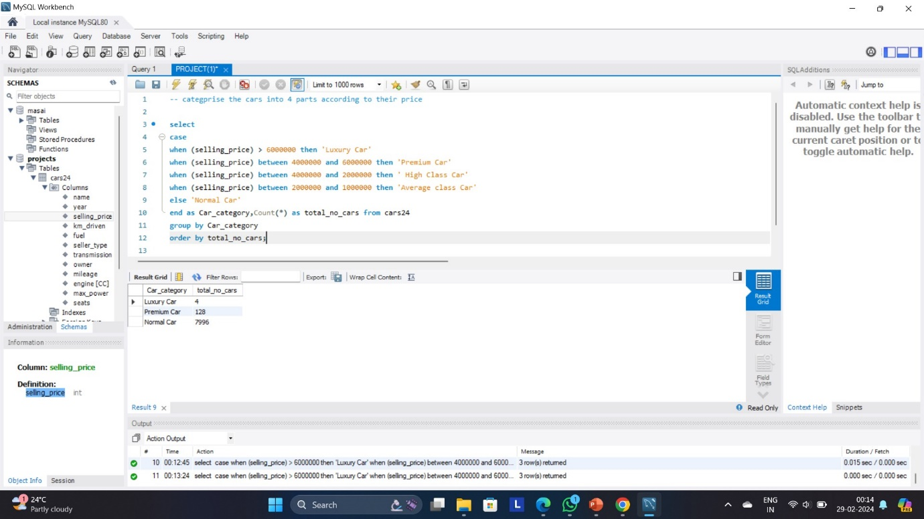

**INSIGHT 9:** print the top 20 cars which is max sold

**QUERY:** select name,count(*) from cars24 group by name order by count(*) desc limit 20;

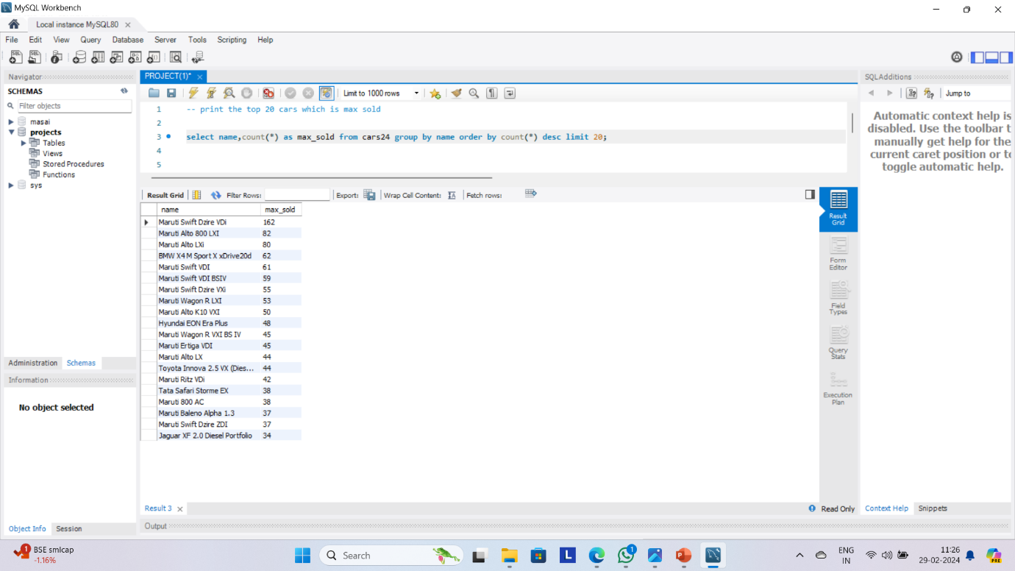

**INSIGHT 10:** print the manual diesel cars which has seating capacity between 7-10 sort the output by highest seat capacity first

**QUERY:** select * from cars24 where transmission=’manual’ and fuel=’diesel’ and seats between 7 and 10 order by seats desc;

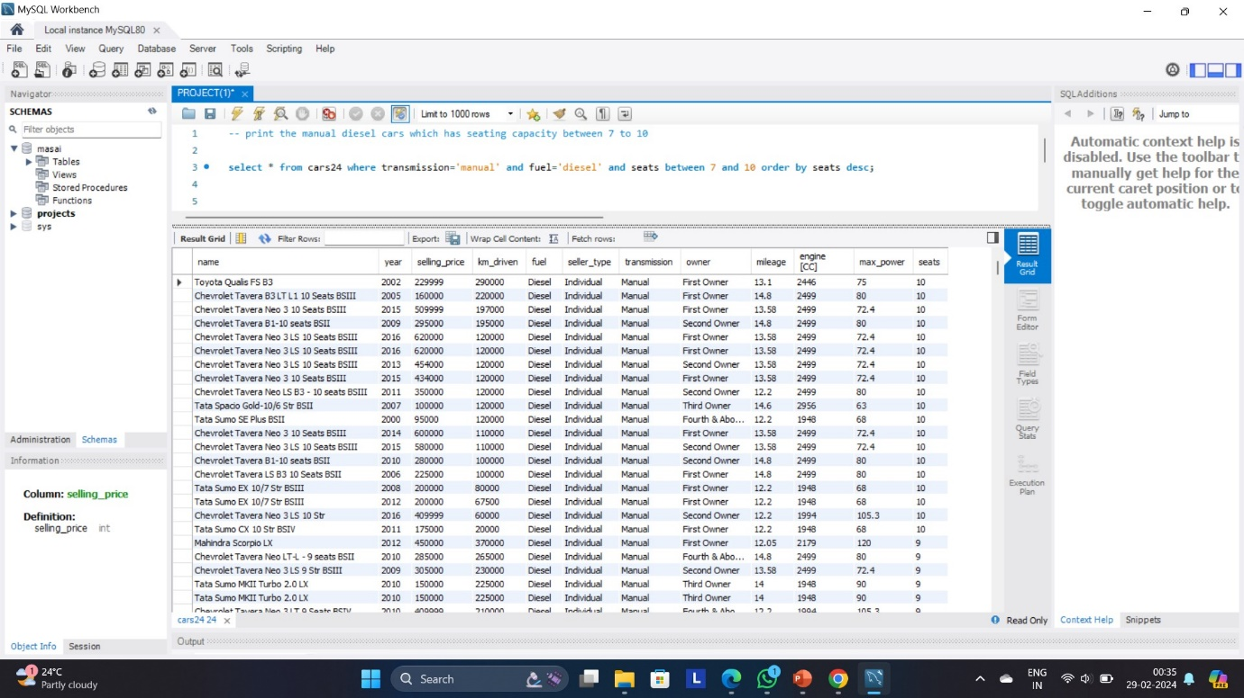

**INSIGHT 11:** count the cars sold by individual in the year 2016

**QUERY:** select count(*) as total_cars_sold from cars24 where year=2016 and seller_type=’individual’;

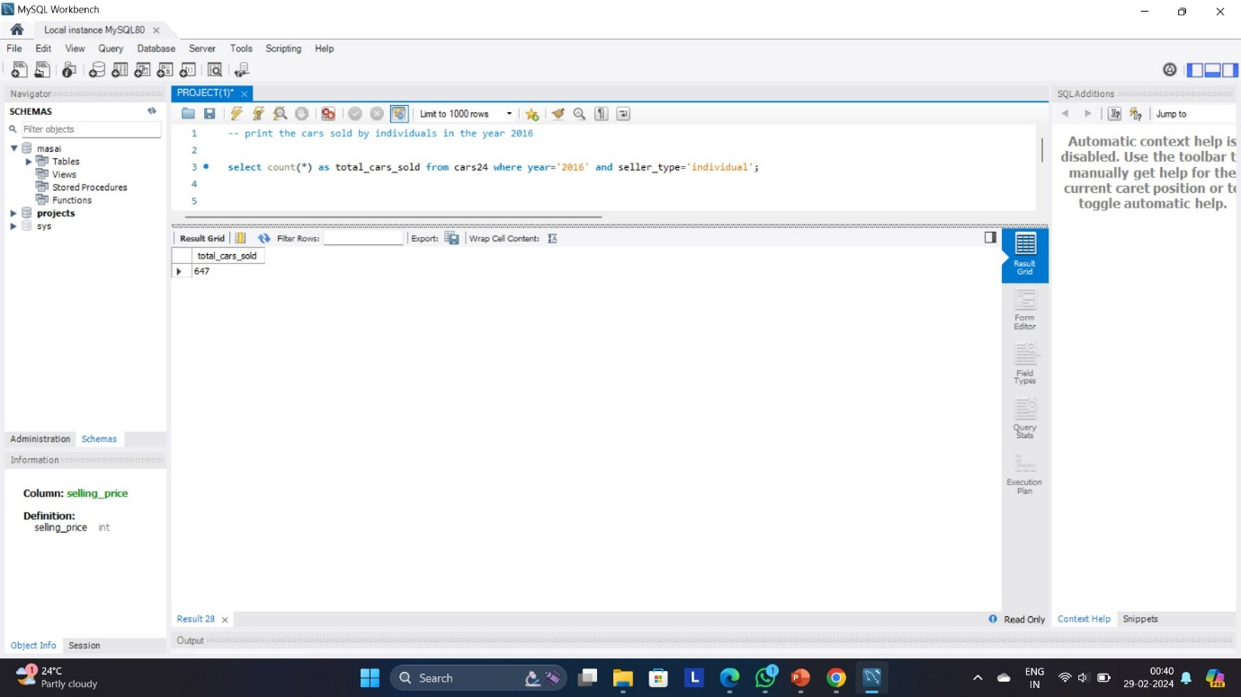

**INSIGHT 11:** print the name, price, fuel type, owner, max_power, seats and average mileage of ambassador car

**QUERY:**

select name, selling_price ,fuel, owner,max_power, seats, avg(mileage) from cars24 where name like '%Ambassador%' group by name, selling_price, fuel, owner, max_power,seats;

